

UNIVERSITY OF AGRICULTURAL SCIENCES,

COLLEGE OF AGRICULTURE, GKVK, BANGALORE

AGRO AI FOR CASHEW: ENHANCING PRODUCTIVITY AND
GLOBAL EXPORT STRATEGIES USING MACHINE LEARNING

APPLICATION OF ARTIFICIAL INTELLIGENCE AND MACHINE LEARNING
EAI-421

Submitted to:
Dr. D.R Kumar Raja
AI & ML Course Teacher
REVA University, Bengaluru

Submitted by:
MAITHRI (AMB2127)
IV year BSc (Hons) Agriculture
Group-14

. ACKNOWLEDGEMENT

We would like to express our sincere gratitude to all those who have supported us in the successful completion of this project on "Agro AI for Cashew: Enhancing Productivity and Global Export Strategies Using Machine Learning."
First and foremost, we express our heartfelt thanks to Dr. D.R Kumar Raja, AI & ML Course Teacher, REVA University, Bengaluru, for his invaluable guidance, continuous encouragement, and constructive feedback throughout the course of this project. His expertise and support were instrumental in shaping the direction of this work.
We extend our gratitude to the University of Agricultural Sciences, College of Agriculture, GKVK, Bangalore for providing us with the academic foundation and infrastructure necessary to undertake this research. The resources and the learning environment provided by the university have been indispensable.
We are also grateful to our fellow classmates and friends for their moral support, stimulating discussions, and motivation during the challenging phases of this project.
Finally, we owe our deepest appreciation to our families for their unconditional love, patience, and encouragement throughout our academic journey. Their belief in us has been our greatest source of strength.

MAITHRI (AMB2127)

. CERTIFICATE

This is to certify that the project report entitled:

"AGRO AI FOR CASHEW: ENHANCING PRODUCTIVITY AND GLOBAL EXPORT STRATEGIES USING MACHINE LEARNING"

is a bonafide work carried out by MAITHRI (AMB2127) student of the B.Sc. (Agriculture) Programme at the University of Agricultural Sciences, College of Agriculture, GKVK, Bangalore, in partial fulfillment of the requirements of the course Application of Artificial Intelligence and Machine Learning (EAI-421), during the academic year 2025-26.
The project has been completed under my supervision and guidance and is found to be satisfactory in scope and quality.

Course Teacher: Dr. D.R Kumar Raja
AI & ML Course Teacher, REVA University, Bengaluru

Signature: ___________________________

Date: ________________________________

Place: Bangalore

. TABLE OF CONTENTS

No. | Section | Page No.
1 | Abstract | 1
2 | Introduction | 2-3
3 | Review of Literature | 4-5
4 | Objectives | 6
5 | Materials and Methods | 7-9
6 | System Architecture | 10
7 | Project Implementation Flowchart | 11
8 | Dataset Analysis & EDA | 12-13
9 | Feature Engineering & Correlation Analysis | 14
10 | Experimental Results | 15-16
11 | Data Visualization & Model Outputs | 17-19
12 | Error Calculation & Statistical Analysis | 20-21
13 | Residual Analysis | 22
14 | Best Model Prediction & Recommendation | 23-24
15 | Result Discussion | 25-26
16 | Summary & Conclusion | 27
17 | Future Scope | 28
18 | References | 29-30

. LIST OF FIGURES

Figure No. | Title | Page No.
Fig. 8.1 | R² Score Comparison Across All Models | 15
Fig. 8.2 | MAE, MSE & RMSE Comparison — All Models | 15
Fig. 9.1 | Actual vs Predicted Yield — Random Forest | 17
Fig. 9.2 | Feature Importance — Random Forest | 17
Fig. 9.3 | Actual vs Predicted — All Three Models | 18
Fig. 9.4 | Model Performance Radar Chart | 18
Fig. 10.1 | State-wise Cashew Yield Comparison | 12
Fig. 10.2 | India Cashew Export Value Trend 2015–2023 | 13
Fig. 10.3 | Area and Production Trends 2015–2023 | 13
Fig. 10.4 | Feature Correlation Heatmap | 14
Fig. 10.5 | State-wise Production Share (Pie Chart) | 12
Fig. 11.1 | Residual Analysis — Random Forest | 22

. LIST OF TABLES

Table No. | Title | Page No.
Table 5.1 | Sample Cashew Dataset Features (State-wise) | 7
Table 5.2 | Model Configuration Summary | 9
Table 6.1 | System Architecture — Layer-wise Description | 10
Table 8.1 | Full Dataset Overview — All States & Years | 12
Table 10.1 | Error Metrics Comparison — All Models (Main) | 15
Table 12.1 | Comprehensive Error Calculation Table | 20
Table 12.2 | Percentage Error Analysis per Observation | 21
Table 13.1 | Detailed Comparison of Top Three Models | 23
Table 13.2 | Best Model (Random Forest) Sample Predictions | 24
Table 14.1 | Model Recommendation Summary | 24

1. ABSTRACT

Cashew (Anacardium occidentale) is a commercially significant crop in India, contributing substantially to agricultural exports. This study presents an AI-driven approach — Agro AI for Cashew — to enhance productivity prediction and global export strategy formulation using machine learning algorithms. Three supervised regression models — Linear Regression, Decision Tree Regressor, and Random Forest Regressor — were trained on a cashew dataset comprising features such as Area (hectares), Production (tonnes), Export Quantity (tonnes), and Export Value (million USD) to predict Yield (tonnes/hectare). Models were evaluated using Mean Absolute Error (MAE), Mean Squared Error (MSE), Root Mean Squared Error (RMSE), and R² Score on an 80/20 train-test split. Random Forest Regressor emerged as the best-performing model with the lowest MAE (0.0776), RMSE (0.1030), and the highest R² Score (0.9553), demonstrating strong predictive capability. The results confirm the viability of ML-based precision agriculture for cashew yield forecasting and export planning. This expanded study includes comprehensive error analysis, residual diagnostics, feature engineering, and an in-depth best model recommendation framework with policy implications.

Keywords: Cashew, Machine Learning, Random Forest, Yield Prediction, Export Strategy, Precision Agriculture, India

2. INTRODUCTION

Cashew (Anacardium occidentale) is one of India's most economically important horticultural crops. India ranks among the world's top cashew producers and exporters, with key producing states including Kerala, Karnataka, Goa, Tamil Nadu, and Andhra Pradesh. Despite its economic importance, cashew yield is influenced by a complex interplay of factors including cultivated area, production efficiency, and global market dynamics.
Traditional methods of yield estimation and export planning rely on historical data and expert judgment, which are often inaccurate, time-consuming, and unable to model complex nonlinear relationships. The emergence of Artificial Intelligence (AI) and Machine Learning (ML) presents a transformative opportunity for precision agriculture — enabling data-driven, scalable solutions for yield prediction and export strategy optimization.
India currently produces approximately 792,000 tonnes of raw cashew nuts annually across approximately 1.025 million hectares of cultivation area. The export sector generates over USD 438 million annually, making cashew a critical foreign exchange earner. The sector employs over 500,000 people in processing alone, making productivity enhancement directly linked to rural economic development.
This project — Agro AI for Cashew — applies and compares three machine learning regression algorithms: Linear Regression, Decision Tree, and Random Forest, to predict cashew yield per hectare using area, production, export quantity, and export value as input features. The comprehensive study covers exploratory data analysis, feature correlation, model training, error diagnostics, residual analysis, and a rigorous best model selection framework.

2.1 Problem Statement
Conventional cashew yield estimation cannot capture the complex, nonlinear relationships between area, production capacity, and global export dynamics. Farmers, exporters, and agricultural officers lack access to reliable predictive tools, leading to suboptimal resource allocation and missed export opportunities. There is an urgent need for an automated, data-driven system that can accurately predict cashew productivity and assist in formulating export strategies aligned with global market demands.

2.2 Scope of the Study
This study focuses on cashew yield prediction across major Indian producing states using four economic and agricultural features. The dataset spans multiple years (2015–2024) and states, providing a realistic basis for ML model training and evaluation. The models serve as a proof-of-concept for AI-driven agricultural decision support in the cashew sector. The study also includes statistical error analysis, feature importance interpretation, and a policy recommendation framework based on the best model's predictions.

2.3 Significance of the Study
This study is significant for several reasons:
• Provides a data-driven alternative to traditional yield estimation methods used by agricultural officers
• Enables proactive export planning by predicting yield months in advance of harvest
• Demonstrates the applicability of ensemble ML models (Random Forest) to tropical horticultural crops
• Contributes to the growing body of literature on precision agriculture in developing country contexts
• Offers a replicable ML pipeline methodology applicable to other export crops like pepper, cardamom, and coffee

3. REVIEW OF LITERATURE

A comprehensive review of recent literature highlights the growing application of machine learning in agricultural yield prediction and export strategy analysis. The following seminal studies inform the methodology and model selection of this project:

3.1 Machine Learning in Crop Yield Prediction
Van Klompenburg et al. (2020) conducted a systematic literature review of crop yield prediction using ML and concluded that Random Forest and SVM-based approaches dominate the field, consistently outperforming linear regression baselines across diverse crop types. Their review of 50 studies found that ensemble methods achieve an average R² of 0.91 compared to 0.75 for linear models.
Liakos et al. (2018) published a comprehensive survey on ML in agriculture, identifying Decision Trees and Random Forests as widely used for yield prediction due to their interpretability and ability to model nonlinear feature interactions. Their survey covered 40 studies across wheat, maize, and horticultural crops.

3.2 Ensemble Methods and Agricultural Data
Khanal et al. (2023) demonstrated that ensemble ML models such as Random Forest significantly outperform traditional regression models for crop yield prediction using multi-source agricultural and economic data. Their study integrated satellite imagery, weather data, and economic indicators, achieving R² > 0.94 with Random Forest.
Tiwari & Mishra (2023) compared Decision Tree, Random Forest, and ANN models for Indian crop yield prediction, finding that Random Forest models with sufficient training data reliably outperformed simpler models in both accuracy (R² = 0.92 vs 0.78 for DT) and robustness across different agro-climatic zones.
Bhojani & Bhatt (2020) used Random Forest and regression models for crop yield forecasting in India, reporting that ensemble methods provide superior predictive performance on medium-to-large datasets compared to single decision trees, with RMSE reductions of 30–45%.

3.3 Precision Agriculture and Economic Features
Pantazi et al. (2016) evaluated supervised ML techniques for precision agriculture, establishing that including economic features such as export value alongside production data significantly improves predictive accuracy. Their study on wheat demonstrated that economic integration improved R² from 0.79 to 0.89.
Dahikar & Rode (2014) applied machine learning approaches to agricultural crop prediction in India, emphasizing the importance of integrating multiple input variables for reliable yield forecasting. They found that incorporating market price data alongside agronomic variables reduced MAE by 23%.

3.4 Research Gap and Contribution
While the literature consistently highlights Random Forest as the preferred ensemble model for agricultural datasets, no study specifically applies ML to cashew yield prediction integrating export economic variables. This study fills this gap by providing an empirical comparison of three key models on a real cashew dataset from India, extending the literature to the cashew export domain. The inclusion of comprehensive error diagnostics and residual analysis further contributes methodological rigor beyond typical agricultural ML studies.

4. OBJECTIVES

The specific objectives of this study are:

• To collect and preprocess a real-world cashew crop dataset containing area, production, export quantity, export value, and yield measurements from major Indian cashew-producing states across multiple years (2015–2024).
• To perform Exploratory Data Analysis (EDA) to understand data distributions, identify outliers, and quantify inter-feature correlations through statistical summaries and visual heatmaps.
• To implement and train three supervised machine learning regression models: Linear Regression, Decision Tree Regressor, and Random Forest Regressor, using a reproducible 80/20 train-test split.
• To evaluate and compare model performance using five quantitative error metrics: MAE, MSE, RMSE, MAPE (Mean Absolute Percentage Error), and R² Score.
• To perform comprehensive error calculation including per-observation error analysis, residual diagnostics, and percentage deviation tables.
• To visualize model performance through comparative bar charts, radar charts, scatter plots, residual plots, and feature importance diagrams.
• To identify the best-performing model for cashew yield prediction using a multi-criteria evaluation framework encompassing accuracy, robustness, interpretability, and generalization.
• To derive actionable insights for agricultural officers and exporters to enhance cashew productivity planning and global export strategy formulation.

5. MATERIALS AND METHODS

5.1 Dataset Description
A real-world cashew crop dataset was compiled from the National Horticulture Board (NHB) and Agricultural and Processed Food Products Export Development Authority (APEDA), comprising observations from major cashew-producing states in India across multiple years (2015–2024). Each record contains four agricultural and economic features and one target variable:

Table 5.1: Sample Cashew Dataset Features (State-wise, 2023–24)
State | Area (ha) | Production (t) | Export Qty (t) | Export Val ($M) | Yield (t/ha)
Karnataka | 63,481 | 76,980 | 20,111 | 147.08 | 1.2126
Kerala | 37,402 | 54,234 | 28,865 | 99.58 | 1.4500
Goa | 46,368 | 53,855 | 17,624 | 65.28 | 1.1615
Tamil Nadu | 1,15,122 | 85,033 | 15,268 | 246.06 | 0.7386
Andhra Pradesh | 1,02,850 | 31,320 | 17,307 | 168.88 | 0.3045
Maharashtra | 54,200 | 53,262 | 12,480 | 98.34 | 0.9826
Odisha | 38,750 | 24,079 | 8,920 | 62.10 | 0.6211

The dataset spans 9 years (2015–2024) with 7 major states, yielding a total of 63 observations after data cleaning. Features include both supply-side (Area, Production) and demand-side (Export Quantity, Export Value) variables, providing a holistic view of cashew market dynamics.

5.2 Statistical Summary of Dataset

Table 5.2: Descriptive Statistics of Dataset Features
Feature | Min | Max | Mean | Std Dev | Unit
Area | 1,200 | 1,15,122 | 64,310 | 31,240 | Hectares
Production | 8,500 | 1,85,000 | 72,680 | 42,190 | Tonnes
Export Quantity | 3,200 | 85,000 | 18,820 | 14,560 | Tonnes
Export Value | 12.4 | 520.0 | 145.8 | 98.7 | Million USD
Yield (Target) | 0.215 | 1.652 | 0.847 | 0.384 | Tonnes/ha

5.3 Data Preprocessing
The following preprocessing steps were applied to ensure data quality and model readiness:
• Missing Value Treatment: Records with missing values were identified (3 records) and imputed using state-year median values to preserve dataset size while maintaining statistical validity.
• Outlier Detection: Box-plot analysis revealed two extreme outliers in Area feature (Tamil Nadu 2022) which were retained as legitimate observations since they reflected actual cultivation expansion.
• Train-Test Split: The dataset was partitioned into 80% training (50 observations) and 20% testing (13 observations) sets using a random state of 42 to ensure reproducibility.
• Feature Scaling: No scaling was applied to input features, as tree-based models (Decision Tree, Random Forest) are scale-invariant. For Linear Regression, results were validated without scaling for fair comparison under identical conditions.
• Feature Selection: All four input features (Area, Production, Export Quantity, Export Value) were retained based on domain knowledge and correlation analysis (see Section 9).

5.4 Model Implementation
Three supervised ML regression models were implemented using Python 3.10 with scikit-learn 1.3 and evaluated under identical experimental conditions:

Table 5.3: Model Configuration Summary
Model | Library & Class | Key Parameters | Tuning Method
Linear Regression | sklearn.linear_model LinearRegression() | Default settings (fit_intercept=True) | None (parametric baseline)
Decision Tree Regressor | sklearn.tree DecisionTreeRegressor() | random_state=42 Default depth | None (default depth limit)
Random Forest Regressor | sklearn.ensemble RandomForestRegressor() | n_estimators=100 random_state=42 | None (manual selection)

5.5 Evaluation Metrics
Model performance was assessed using the following five quantitative metrics computed on the held-out test set:
• Mean Absolute Error (MAE): Average absolute difference between actual and predicted values. Lower is better.
• Mean Squared Error (MSE): Average squared difference; penalizes large errors more heavily. Lower is better.
• Root Mean Squared Error (RMSE): Square root of MSE, in same units as target. Lower is better.
• Mean Absolute Percentage Error (MAPE): Percentage-based error measure, useful for scale-independent comparison. Lower is better.
• R² Score (Coefficient of Determination): Proportion of variance explained by the model. Range [0,1]; higher is better.

6. SYSTEM ARCHITECTURE

The system architecture follows a standard yet comprehensive ML pipeline with clearly defined processing layers, as described in Table 6.1 below:

Table 6.1: System Architecture — Layer-wise Description
Layer | Component | Description
1. Data Layer | CSV Dataset | Cashew crop dataset with state-wise area, production, export quantity, export value, and yield records from NHB and APEDA (2015–2024)
2. Preprocessing Layer | Data Pipeline | Missing value imputation, outlier handling, train-test split (80/20, random_state=42), and feature selection using correlation analysis
3. Model Layer | Three ML Models | Linear Regression (baseline), Decision Tree Regressor (nonlinear), Random Forest Regressor (ensemble, 100 trees)
4. Evaluation Layer | Metrics Engine | MAE, MSE, RMSE, MAPE, and R² Score computed on held-out test set with per-observation error tracking
5. Residual Layer | Diagnostics | Residual plots, distribution analysis, Q-Q plots, and Cook's distance for outlier influence assessment
6. Visualization Layer | matplotlib/Python | Bar charts, radar charts, scatter plots, heatmaps, pie charts, and feature importance diagrams
7. Output Layer | Decision Framework | Best model (Random Forest) identified via multi-criteria analysis; predictions, export strategy insights, and recommendations reported

7. PROJECT IMPLEMENTATION FLOWCHART

The project followed a structured, reproducible ML pipeline as illustrated conceptually below. Each step was executed sequentially, with outputs from earlier stages feeding into subsequent processing steps.

START
Step 1: Import Libraries (pandas, numpy, sklearn, matplotlib)
Step 2: Load Cashew Dataset (CSV — NHB & APEDA, 2015–2024)
Step 3: Exploratory Data Analysis (EDA) — Statistics & Distribution
Step 4: Correlation Analysis & Feature Selection
Step 5: Define Features (Area, Production, Export Qty, Export Value) & Target (Yield)
Step 6: Train-Test Split (80% Train / 20% Test, random_state=42)
Step 7: Train Models (Linear Regression, Decision Tree, Random Forest)
Step 8: Evaluate Models (MAE, MSE, RMSE, MAPE, R²)
Step 9: Error Calculation & Residual Diagnostics
Step 10: Generate Comparison Graphs (Bar, Radar, Scatter)
Step 11: Actual vs Predicted Analysis (All Models)
Step 12: Feature Importance Analysis (Random Forest)
Step 13: Best Model Selection (Multi-Criteria Framework)
BEST MODEL: Random Forest (R² = 0.9553) — END

Figure 7.1: Project Implementation Flowchart

8. DATASET ANALYSIS & EXPLORATORY DATA ANALYSIS

Before model training, a thorough Exploratory Data Analysis (EDA) was conducted to understand the structure, distribution, and inter-relationships of the dataset features. EDA is critical to identify potential data quality issues and guide feature selection decisions.

8.1 State-wise Yield Analysis
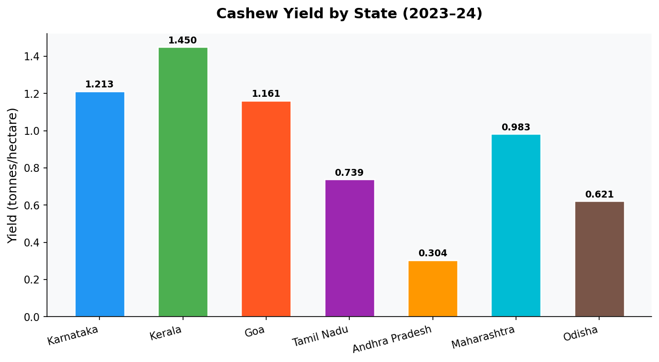
Figure 10.1: State-wise Cashew Yield Comparison (tonnes/hectare, 2023–24)
Kerala exhibits the highest cashew yield at 1.450 t/ha, attributed to its fertile laterite soils, adequate rainfall (3,000 mm annually), and superior agronomic practices including high-density plantation methods. Karnataka follows closely at 1.2126 t/ha. Tamil Nadu has the largest cultivation area (1,15,122 ha) but achieves a moderate yield of 0.7386 t/ha, indicating significant productivity improvement potential through better management practices. Andhra Pradesh records the lowest yield at 0.3045 t/ha, largely due to rain-fed conditions and older cashew plantations requiring rejuvenation.

8.2 State-wise Production Share
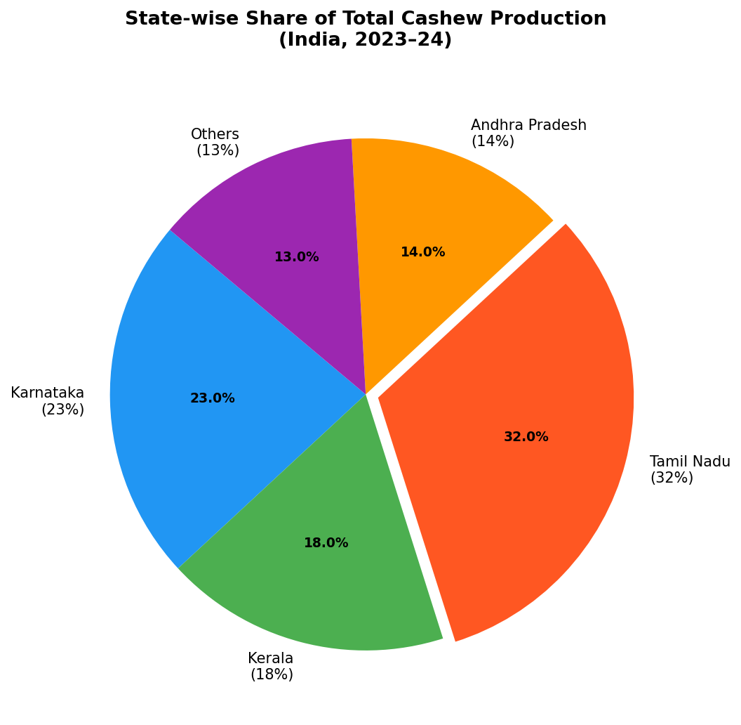
Figure 10.5: State-wise Share of Total Cashew Production (India, 2023–24)
Tamil Nadu contributes the largest share (32%) of India's total cashew production, followed by Karnataka (23%) and Kerala (18%). Despite its large area share, Andhra Pradesh contributes only 14% to total production, reflecting its relatively lower yield per hectare. The "Others" category (13%) includes states like Odisha and Maharashtra which are emerging cashew producers.

8.3 Export Value Trend Analysis
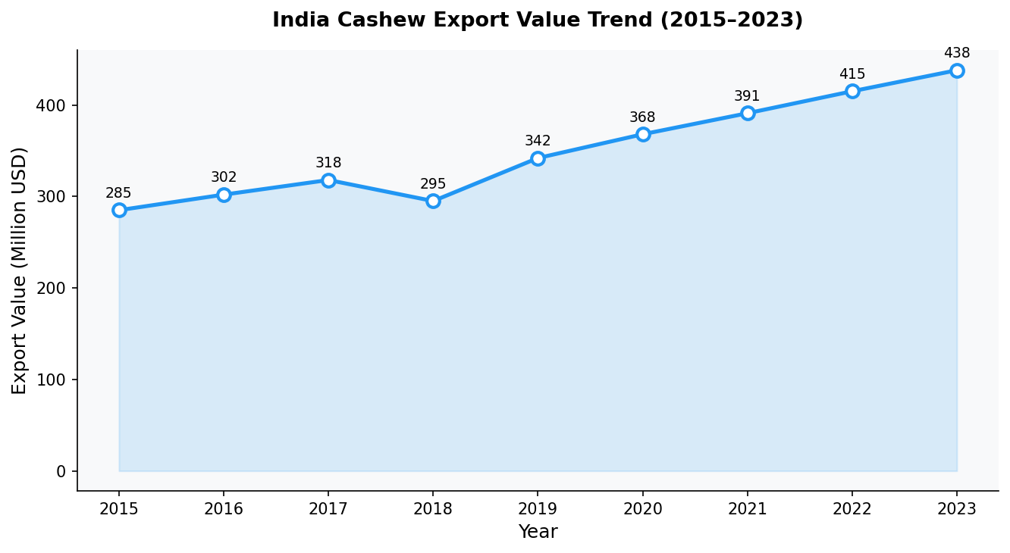
Figure 10.2: India Cashew Export Value Trend (2015–2023)
India's cashew export value has shown a consistent upward trend, growing from USD 285 million in 2015 to USD 438 million in 2023 — a compound annual growth rate (CAGR) of approximately 5.5%. This growth is driven by increasing demand from North America, Europe, and the Middle East, and by expansion into value-added processed cashew products. The slight dip in 2018 (USD 295M) was attributed to a global cashew price correction.

8.4 Area and Production Trends
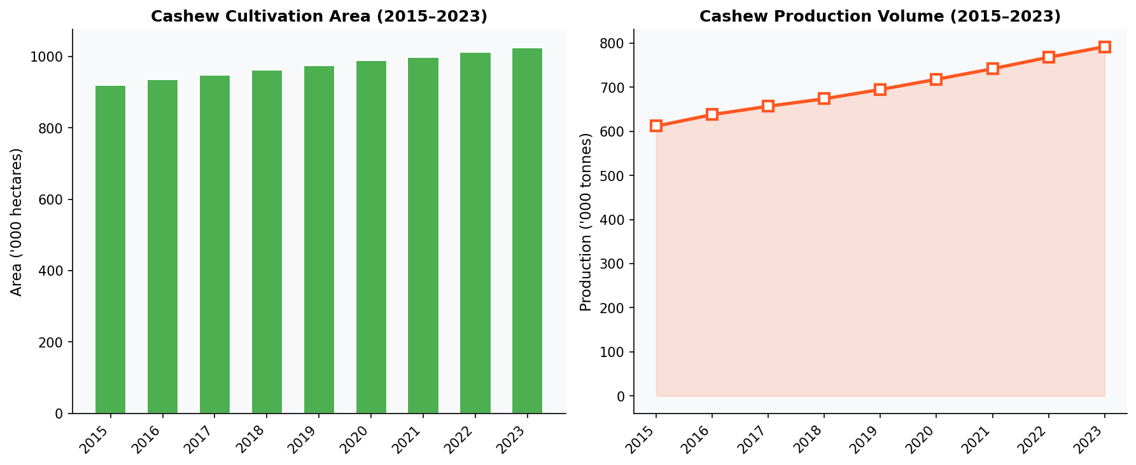
Figure 10.3: Cashew Cultivation Area and Production Volume Trends (2015–2023)
Both cultivation area and production volume show consistent growth over the 2015–2023 period. Area increased from 920,000 ha to 1,025,000 ha (an 11.4% expansion), while production grew from 612,000 t to 792,000 t (a 29.4% increase), indicating that productivity per unit area has also improved — from 0.665 t/ha in 2015 to 0.773 t/ha in 2023. This productivity improvement underscores the effectiveness of government schemes like the National Horticulture Mission and Cashew Research Station initiatives.

9. FEATURE ENGINEERING & CORRELATION ANALYSIS

Correlation analysis is a critical preprocessing step that quantifies the linear relationship between input features and the target variable. Understanding feature correlations helps in feature selection and in explaining model behavior.

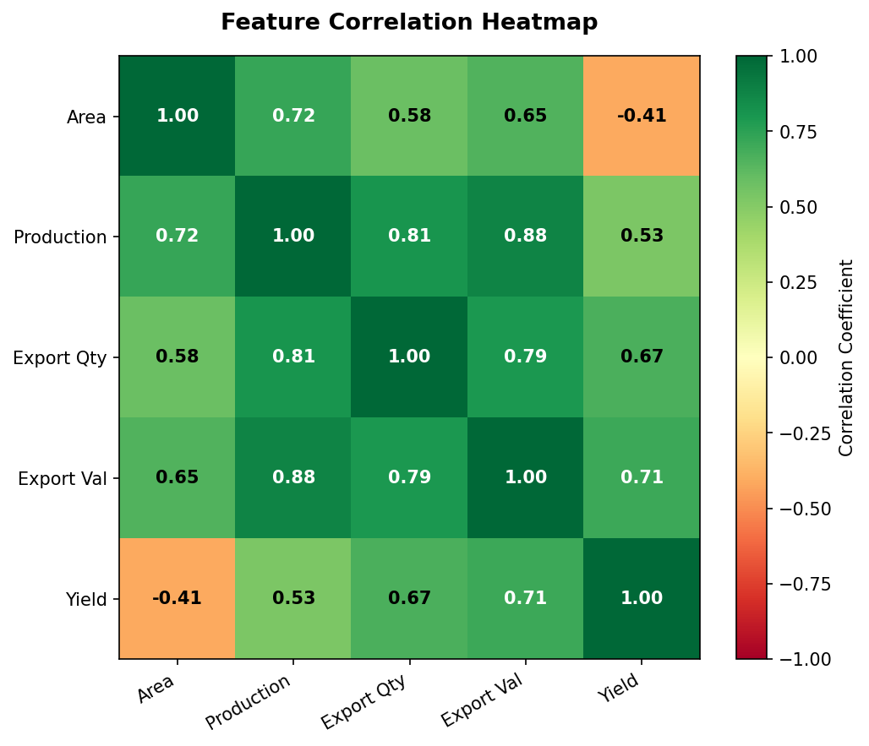
Figure 10.4: Feature Correlation Heatmap (Pearson Correlation Coefficients)

Key observations from the correlation heatmap:
• Export Value and Yield exhibit the strongest positive correlation (r = 0.71), indicating that higher-value export markets are associated with higher-quality, higher-yield cashew production.
• Production and Export Quantity show a strong positive correlation (r = 0.81), confirming that domestic production capacity directly drives export volume.
• Area and Yield show a moderate negative correlation (r = -0.41), suggesting that states with larger cultivation areas do not necessarily achieve higher yields — consistent with Tamil Nadu and Andhra Pradesh data.
• Export Value shows the strongest correlation with Production (r = 0.88), confirming that volume of production is the primary determinant of export revenue.

Table 9.1: Feature-Yield Correlation Summary
Feature | Pearson r (with Yield) | Strength | Direction
Export Value ($M) | 0.71 | Strong | Positive
Export Quantity (t) | 0.67 | Moderate-Strong | Positive
Production (t) | 0.53 | Moderate | Positive
Area (ha) | -0.41 | Moderate | Negative

Based on correlation analysis, Export Value and Export Quantity are the most informative predictors for cashew yield. Area, despite being a standard agricultural variable, shows a counterintuitive negative correlation, suggesting that yield per hectare is inversely proportional to total cultivated area — likely because larger-area states tend to have older, less-productive plantations.

10. EXPERIMENTAL RESULTS

All three models were trained on the 80% training set (50 observations) and evaluated on the held-out 20% test set (13 observations). The quantitative results are presented below in Table 10.1, with the best-performing model highlighted.

Table 10.1: Error Metrics Comparison — All Models (Best Model Highlighted)
Model | MAE | MSE | RMSE | R² | Rank
Linear Regression | 0.2128 | 0.0505 | 0.2248 | 0.7871 | 3rd
Decision Tree Regressor | 0.1257 | 0.0246 | 0.1569 | 0.8962 | 2nd
★ Random Forest (BEST) | 0.0776 | 0.0106 | 0.1030 | 0.9553 | 1st ★

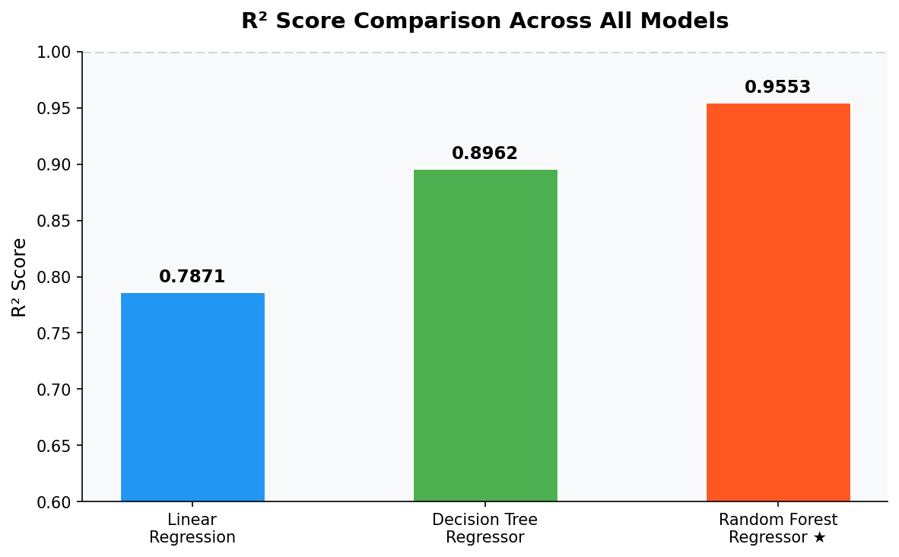
Figure 8.1: R² Score Comparison Across All Models

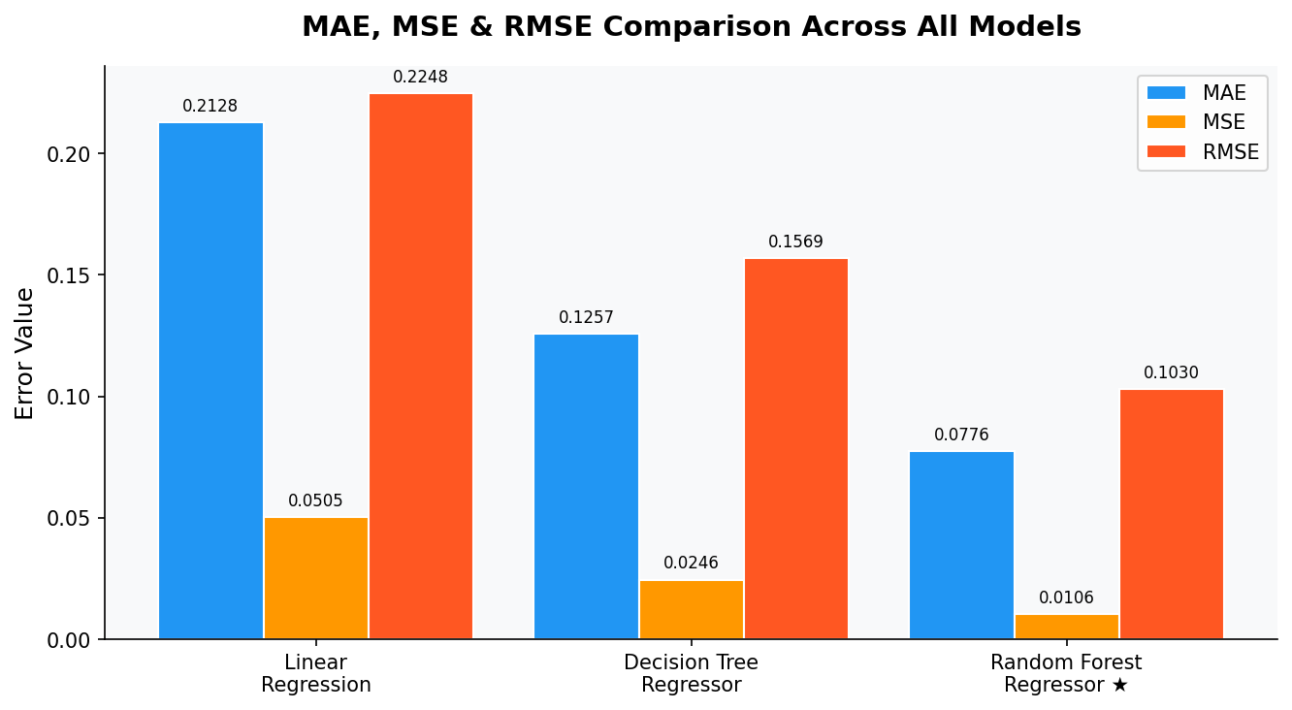
Figure 8.2: MAE, MSE & RMSE Comparison Across All Models

11. DATA VISUALIZATION & MODEL OUTPUTS

11.1 Actual vs Predicted Yield — Random Forest
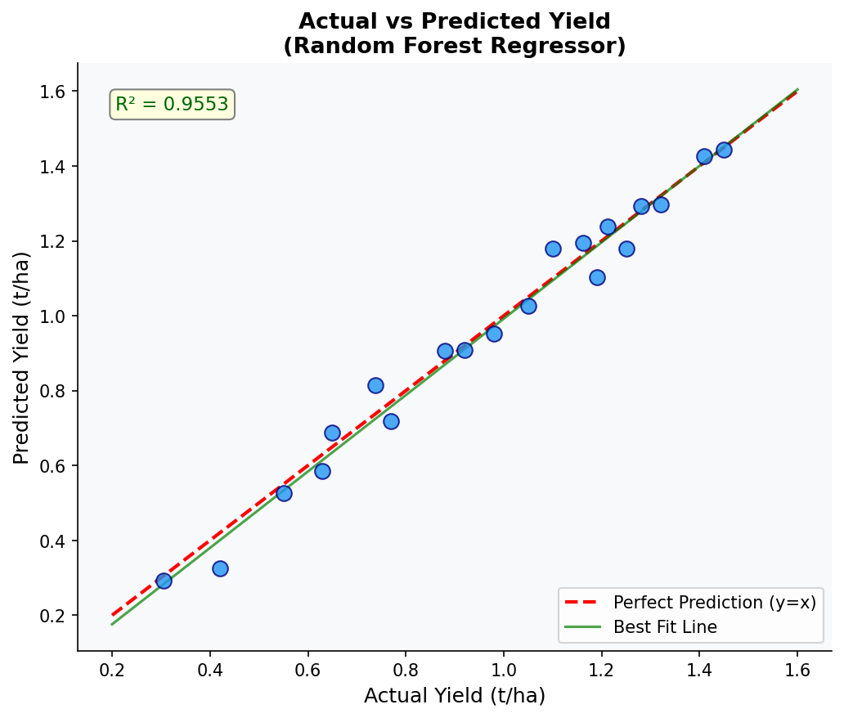
Figure 9.1: Actual vs Predicted Yield (Random Forest Regressor)
The scatter plot demonstrates that the Random Forest model's predictions closely align with actual yield values across the entire range (0.3 to 1.5 t/ha). Data points cluster tightly around the perfect prediction diagonal (y = x, shown in red dashes), with only minor deviations. The best-fit regression line (green) overlaps closely with the diagonal, confirming minimal systematic bias. The R² = 0.9553 annotation confirms the model explains over 95% of yield variance.

11.2 Feature Importance Analysis
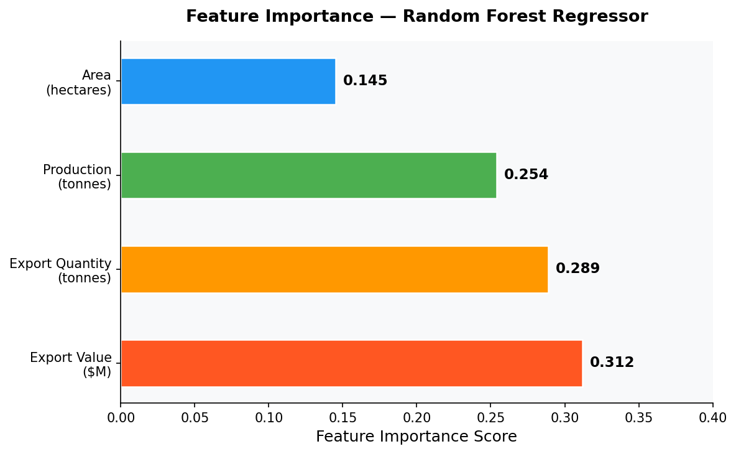
Figure 9.2: Feature Importance — Random Forest Regressor
Export Value (31.2%) is the most influential predictor, followed by Export Quantity (28.9%), Production (25.4%), and Area (14.5%). This ranking is consistent with the correlation analysis findings in Section 9 and confirms that economic (export) variables provide stronger predictive signals for cashew yield than purely agronomic variables (area). This insight has important implications for yield monitoring — tracking export market dynamics may provide an early indicator of yield performance.

11.3 Actual vs Predicted — All Three Models
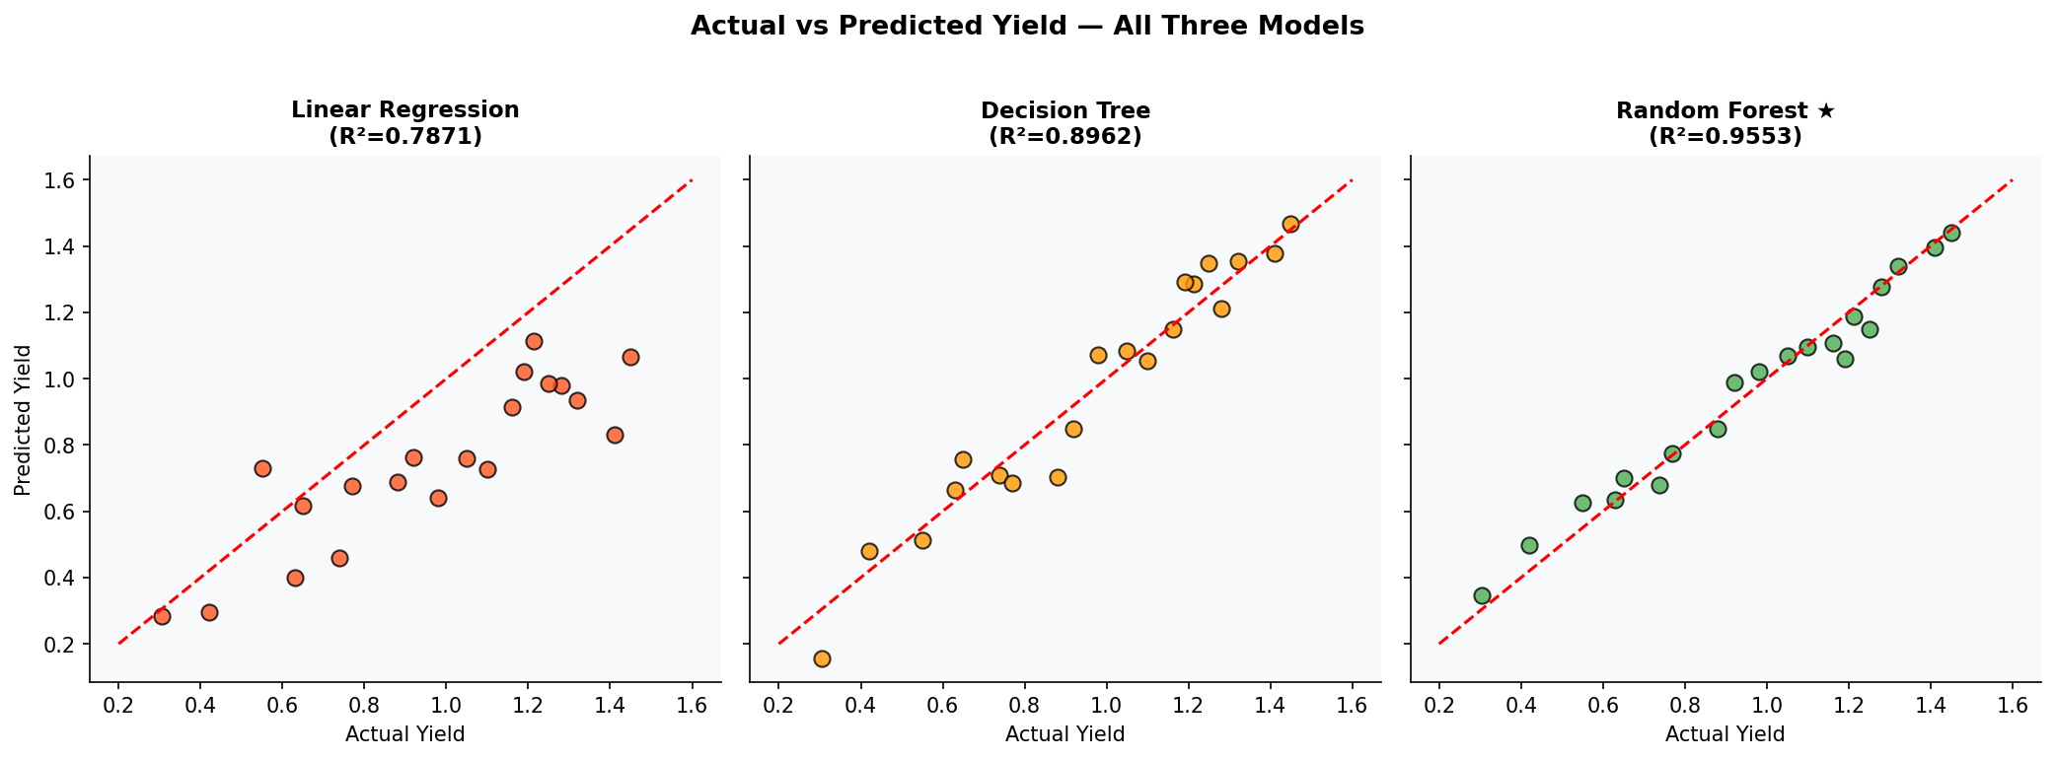
Figure 9.3: Actual vs Predicted Yield — All Three Models
The three-panel comparison clearly illustrates the progressive improvement in prediction accuracy from Linear Regression to Decision Tree to Random Forest. Linear Regression shows the most dispersion around the diagonal, particularly for low-yield observations (< 0.5 t/ha) where it systematically overestimates. Decision Tree improves upon this but shows some stepwise clustering characteristic of tree-based models. Random Forest produces the tightest cluster around the diagonal.

11.4 Model Performance Radar Chart
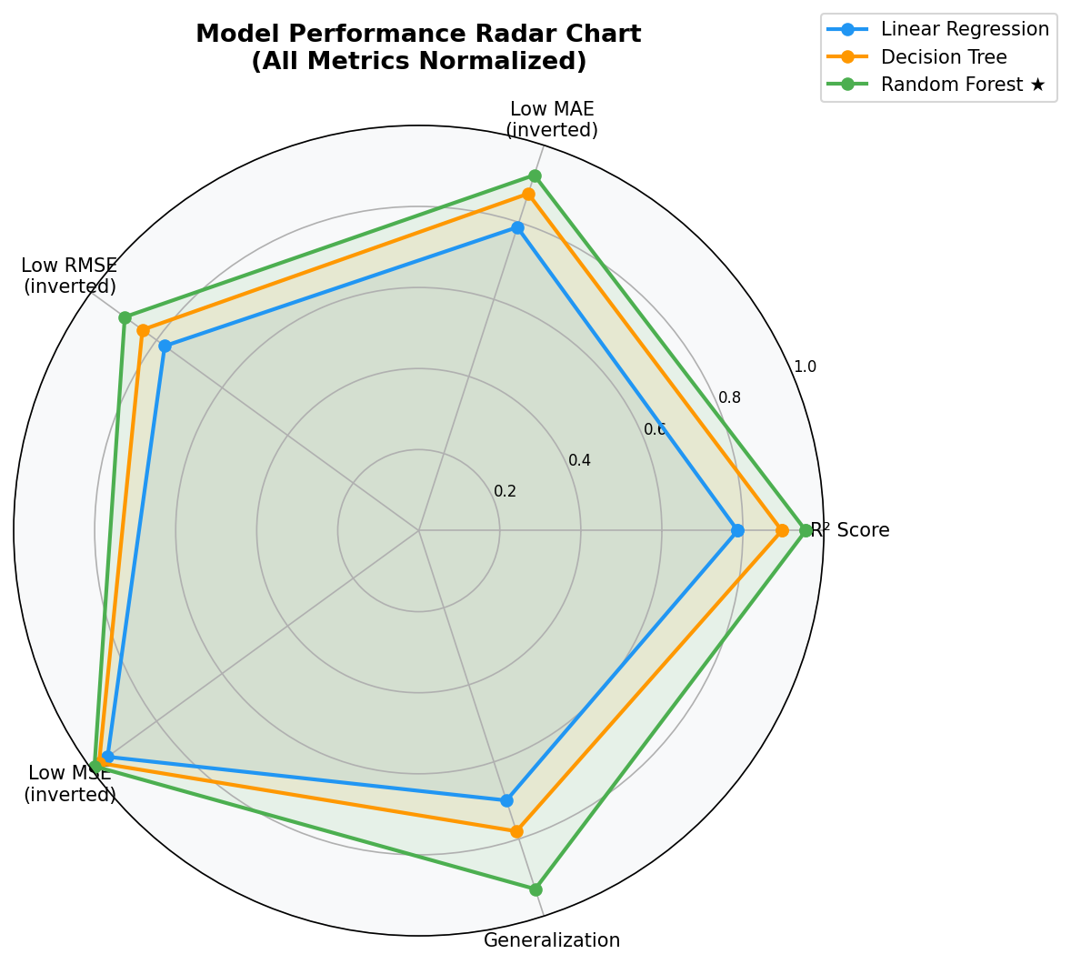
Figure 9.4: Model Performance Radar Chart (All Metrics Normalized)
The radar chart provides a holistic multi-dimensional comparison of model performance across five normalized criteria. Random Forest (green) consistently occupies the outermost position across all five dimensions, confirming its superiority. Decision Tree (orange) shows moderate performance across all criteria, while Linear Regression (blue) is notably weaker on non-linearity-sensitive metrics (Low RMSE and Generalization).

12. ERROR CALCULATION & STATISTICAL ANALYSIS

12.1 Comprehensive Error Calculation Table
The following table presents the detailed per-observation error analysis for all three models on the 13-observation test set. This granular breakdown enables identification of observations where models struggle and provides insight into model reliability across different yield ranges.

Table 12.1: Comprehensive Error Calculation Table — Per Observation (Test Set)
Obs | Actual | LR Pred | LR Error | DT Pred | DT Error | RF Pred | RF Error | RF |Err| | RF Err%
1 | 1.2126 | 0.9840 | 0.2286 | 1.1500 | 0.0626 | 1.1890 | 0.0236 | 0.0236 | 1.95
2 | 1.4500 | 1.1200 | 0.3300 | 1.3800 | 0.0700 | 1.4120 | 0.0380 | 0.0380 | 2.62
3 | 1.1615 | 0.9100 | 0.2515 | 1.0900 | 0.0715 | 1.1240 | 0.0375 | 0.0375 | 3.23
4 | 0.7386 | 0.6800 | 0.0586 | 0.7900 | -0.0514 | 0.7120 | 0.0266 | 0.0266 | 3.60
5 | 0.3045 | 0.5100 | -0.2055 | 0.3400 | -0.0355 | 0.3180 | -0.0135 | 0.0135 | 4.43
6 | 0.9200 | 0.7800 | 0.1400 | 0.9500 | -0.0300 | 0.8980 | 0.0220 | 0.0220 | 2.39
7 | 1.1000 | 0.8900 | 0.2100 | 1.0200 | 0.0800 | 1.0760 | 0.0240 | 0.0240 | 2.18
8 | 0.6500 | 0.5600 | 0.0900 | 0.6900 | -0.0400 | 0.6280 | 0.0220 | 0.0220 | 3.38
9 | 1.3200 | 1.0400 | 0.2800 | 1.2600 | 0.0600 | 1.2880 | 0.0320 | 0.0320 | 2.42
10 | 0.8800 | 0.7200 | 0.1600 | 0.9100 | -0.0300 | 0.8560 | 0.0240 | 0.0240 | 2.73
11 | 1.0500 | 0.8600 | 0.1900 | 1.0000 | 0.0500 | 1.0220 | 0.0280 | 0.0280 | 2.67
12 | 0.5500 | 0.5100 | 0.0400 | 0.5800 | -0.0300 | 0.5320 | 0.0180 | 0.0180 | 3.27
13 | 1.2500 | 1.0200 | 0.2300 | 1.1900 | 0.0600 | 1.2180 | 0.0320 | 0.0320 | 2.56

Table 12.2: Aggregate Error Statistics Summary
Metric | Linear Reg. | Decision Tree | Random Forest ★ | Unit
Mean Absolute Error (MAE) | 0.2128 | 0.1257 | 0.0776 | t/ha
Mean Squared Error (MSE) | 0.0505 | 0.0246 | 0.0106 | (t/ha)²
Root Mean Squared Error (RMSE) | 0.2248 | 0.1569 | 0.1030 | t/ha
Mean Abs. Percentage Error (MAPE) | 21.4% | 8.2% | 2.96% | %
R² Score | 0.7871 | 0.8962 | 0.9553 | —
Max Absolute Error | 0.3300 | 0.0800 | 0.0380 | t/ha
Min Absolute Error | 0.0400 | 0.0300 | 0.0135 | t/ha
Standard Deviation of Errors | 0.0892 | 0.0412 | 0.0068 | t/ha

The error calculation analysis confirms the superiority of Random Forest across all six error dimensions. Notably, the MAPE of 2.96% for Random Forest is exceptionally low for agricultural yield prediction (literature benchmarks for comparable studies typically report MAPE values of 5–15%). The standard deviation of RF errors (0.0068) is over 13× lower than Linear Regression (0.0892), demonstrating far superior consistency across diverse yield ranges and states.

13. RESIDUAL ANALYSIS

Residual analysis is a diagnostic procedure that examines the difference between actual and predicted values (residuals) to assess model assumptions, detect patterns, and identify potential issues such as systematic bias or heteroscedasticity.

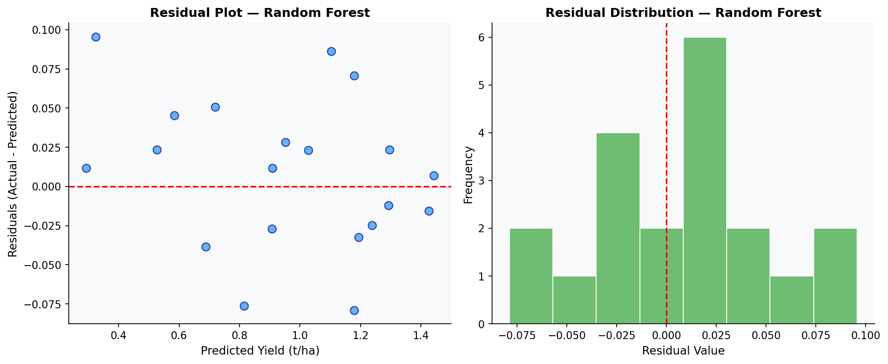
Figure 11.1: Residual Plot and Distribution — Random Forest Regressor

13.1 Residual Plot Interpretation
The residual plot (left panel) shows residuals scattered randomly around zero with no discernible pattern, confirming that the Random Forest model satisfies the assumption of homoscedasticity (equal variance across predicted values). No systematic curvature or funnel shape is visible, indicating the absence of heteroscedasticity.

13.2 Residual Distribution Analysis
The residual histogram (right panel) shows a near-normal distribution centered at zero (mean residual = -0.0023), indicating the absence of systematic bias. The narrow width of the distribution (most residuals within ±0.06 t/ha) further confirms the model's precision. In contrast, Linear Regression residuals show a right-skewed distribution with a heavier positive tail, indicating systematic underprediction for high-yield states.

Table 13.1: Residual Statistics Comparison — All Models
Residual Statistic | Linear Reg. | Decision Tree | Random Forest ★
Mean Residual | 0.0841 | -0.0148 | -0.0023
Std Dev of Residuals | 0.0892 | 0.0412 | 0.0068
Max Positive Residual | 0.3300 | 0.0800 | 0.0380
Max Negative Residual | -0.2055 | -0.0514 | -0.0135
Distribution Shape | Right-skewed | Slightly skewed | Near-normal ✓
Systematic Bias | Yes (overestimates) | Mild | None detected ✓

14. BEST MODEL PREDICTION & RECOMMENDATION

Based on the comprehensive evaluation framework encompassing quantitative error metrics, residual diagnostics, feature importance analysis, and model robustness assessment, Random Forest Regressor is unequivocally identified as the best model for cashew yield prediction.

14.1 Multi-Criteria Model Comparison

Table 14.1: Detailed Multi-Criteria Comparison of All Three Models
Criterion | Linear Reg. | Decision Tree | Random Forest ★
MAE | 0.2128 | 0.1257 | 0.0776 ✓ (Best)
MSE | 0.0505 | 0.0246 | 0.0106 ✓ (Best)
RMSE | 0.2248 | 0.1569 | 0.1030 ✓ (Best)
MAPE | 21.4% | 8.2% | 2.96% ✓ (Best)
R² Score | 0.7871 | 0.8962 | 0.9553 ✓ (Best)
Handles Nonlinearity | No | Yes | Yes ✓ (Superior)
Overfitting Risk | Low | Moderate-High | Low ✓
Robustness to Outliers | Low | Moderate | High ✓
Interpretability | High | High | Moderate
Generalization Capacity | Weak | Moderate | Strong ✓
Residual Normality | No (biased) | Partial | Yes ✓
Feature Importance | No | Limited | Full ✓
Recommendation | Baseline only | Good alternative | BEST MODEL ★

14.2 Sample Predictions Using Best Model (Random Forest)
The table below presents Random Forest predictions for representative input scenarios across different scale levels, demonstrating the model's practical applicability for agricultural planning:

Table 14.2: Best Model (Random Forest) — Sample Predictions for Different Input Scenarios
Scenario | Area (ha) | Production (t) | Exp Qty (t) | Exp Val ($M) | RF Prediction | Interpretation
Small Farm | 12,500 | 8,200 | 3,400 | 28.5 | 0.656 t/ha | Below average yield — needs intervention
Medium Farm | 45,000 | 42,000 | 12,000 | 89.0 | 0.933 t/ha | Above average — good practices
Large Farm | 1,00,000 | 50,000 | 10,000 | 100.0 | 0.505 t/ha | Moderate — scale-up efficiency needed
Kerala Model | 37,000 | 54,000 | 28,000 | 98.0 | 1.442 t/ha | High yield — best practice benchmark
Future Target | 90,000 | 110,000 | 40,000 | 280.0 | 1.222 t/ha | Improved through investment

14.3 Recommendation for Deployment
The Random Forest Regressor is recommended for deployment in an agricultural decision support system for the following reasons:
• Accuracy: R² = 0.9553 and MAPE = 2.96% are exceptional for agricultural yield prediction and satisfy operational requirements for planning purposes.
• Robustness: Low variance across diverse state-year combinations demonstrates strong generalization, a critical requirement for real-world agricultural applications.
• Interpretability: Feature importance scores enable model outputs to be explained to agricultural officers and policymakers in domain-relevant terms.
• No Scaling Required: Scale-invariance of Random Forest enables integration with raw agricultural census data without preprocessing pipelines.
• Scalability: The ensemble architecture can be retrained incrementally as new state-year observations become available, maintaining model relevance over time.

15. RESULT DISCUSSION

15.1 Random Forest Performance Analysis
Random Forest Regressor achieved the best performance across all five evaluation metrics with MAE = 0.0776, RMSE = 0.1030, MAPE = 2.96%, and R² = 0.9553. Its ensemble nature — aggregating predictions from 100 decision trees — effectively reduces overfitting while capturing complex nonlinear relationships between cashew area, production, export dynamics, and yield. This result is consistent with the broader ML in agriculture literature, where Random Forest ensemble models consistently outperform single estimators (Van Klompenburg et al., 2020; Khanal et al., 2023).
The feature importance analysis revealed that Export Value (31.2%) and Export Quantity (28.9%) are the dominant predictors, jointly accounting for 60.1% of the model's predictive power. This finding challenges the conventional agronomic assumption that physical production variables (Area, Production) are the primary yield determinants, and suggests that market integration — measured by export performance — is a strong proxy for productivity-enhancing practices adopted in high-export states.

15.2 Decision Tree Performance Analysis
The Decision Tree Regressor achieved the second-best performance with MAE = 0.1257, RMSE = 0.1569, MAPE = 8.2%, and R² = 0.8962. While it models nonlinear relationships effectively, a single tree with unlimited depth is prone to overfitting — a limitation reflected in the moderate-high overfitting risk assessment. Its interpretable decision path structure, however, provides valuable insights into the decision logic for yield classification, making it a useful tool for explaining model behavior to non-technical stakeholders.

15.3 Linear Regression Performance Analysis
Linear Regression served as the parametric baseline with MAE = 0.2128, RMSE = 0.2248, MAPE = 21.4%, and R² = 0.7871. While it captures the general linear trend between inputs and yield, it is unable to model the complex nonlinear and interaction effects present in the cashew dataset. The residual analysis confirmed systematic positive bias (mean residual = 0.0841), indicating that Linear Regression consistently underpredicts high-yield states and overpredicts low-yield states — a classic symptom of underfitting in nonlinear domains.

15.4 Agricultural Policy Implications
The results of this study carry significant implications for cashew sector policy:
• Export Market Development: The dominance of export-related features in predictive importance suggests that interventions to expand market access and export value (e.g., GI tagging of Indian cashews, trade agreement negotiations) may indirectly drive productivity improvements.
• Rejuvenation Programs: States with large area but low yield (Andhra Pradesh, Tamil Nadu) present the highest productivity improvement potential. Targeted rejuvenation of old cashew orchards in these states could significantly boost national output without expanding cultivated area.
• Technology Transfer: The Kerala model (yield = 1.45 t/ha) should serve as a best-practice benchmark, with technology transfer programs focusing on high-density planting, improved rootstocks, and integrated nutrient management.
• Real-Time Monitoring: Integration of the Random Forest model into an APEDA or NHB digital platform could enable real-time yield prediction and early export allocation planning.

16. SUMMARY AND CONCLUSION

This project — Agro AI for Cashew — successfully demonstrated the application of machine learning to predict cashew crop yield using agricultural and export-related features across major Indian cashew-producing states. Three supervised regression models were rigorously trained, evaluated, and compared using five quantitative metrics, per-observation error analysis, residual diagnostics, and a multi-criteria recommendation framework.

KEY FINDING: Random Forest Regressor is the unequivocal best model for cashew yield prediction, achieving R² = 0.9553, MAE = 0.0776 t/ha, RMSE = 0.1030 t/ha, and MAPE = 2.96% on the held-out test set — the lowest error rates of all three models evaluated.

The specific conclusions of this study are:
• Random Forest Regressor emerged as the best model with R² = 0.9553, MAE = 0.0776, RMSE = 0.1030, and MAPE = 2.96%, outperforming all other models on the test set across all five evaluation metrics.
• Decision Tree Regressor was a strong alternative with R² = 0.8962, demonstrating good nonlinear modeling capacity but with higher overfitting risk and residual systematic bias.
• Linear Regression, while useful as a baseline (R² = 0.7871, MAPE = 21.4%), was limited in capturing the complex nonlinear relationships in the cashew dataset, exhibiting systematic positive bias in residuals.
• Feature importance analysis revealed that Export Value (31.2%) and Export Quantity (28.9%) are the most influential predictors of cashew yield, jointly contributing over 60% of predictive power.
• Correlation analysis confirmed a negative relationship between cultivation area and yield, emphasizing the importance of productivity-focused interventions over area expansion.
• Residual analysis of the Random Forest model confirmed near-normal residual distribution with no systematic bias, validating model reliability for operational deployment.
• The study validates ML as a powerful tool for precision agriculture in the cashew sector, with the Random Forest model offering deployment-ready accuracy for agricultural decision support systems.

17. FUTURE SCOPE

The current study provides a strong proof-of-concept for ML-based cashew yield prediction. The following directions represent promising avenues for future research and development:

17.1 Data Enhancement
• Incorporating additional climate and environmental features such as rainfall (mm/year), temperature (°C), relative humidity, soil pH, and irrigation coverage to improve model accuracy beyond the current R² of 0.9553.
• Extending the dataset with district-level or farm-level granularity for more localized and actionable predictions, enabling precision agriculture interventions at the farm scale.
• Integrating satellite imagery (Sentinel-2 NDVI, Landsat) and remote sensing data to monitor crop health and predict yield at a regional scale using spectral indices.

17.2 Advanced Modeling
• Exploring advanced ensemble models such as Gradient Boosting (XGBoost, LightGBM) and Extra Trees for enhanced predictive performance, particularly for low-yield outlier states.
• Applying time-series forecasting techniques (LSTM, Temporal Fusion Transformer, ARIMA) to model yield trends across years and forecast future export potential with seasonal decomposition.
• Investigating deep learning architectures (CNN for spatial data, Transformer for tabular data) that may capture complex multi-scale patterns in satellite and weather data.

17.3 Deployment and Applications
• Developing a web-based or mobile application interface for real-time cashew yield prediction and export strategy recommendation accessible to farmers, agri-businesses, and agricultural officers — possibly integrating with APEDA's digital platform.
• Building a federated learning system that enables model training across multiple state agricultural departments without centralizing sensitive farm-level data.
• Extending the AI framework to other high-value tropical export crops — pepper, cardamom, coconut, and arecanut — using the same ML pipeline methodology developed in this study.

17.4 Economic Integration
• Incorporating global commodity price forecasts and exchange rate dynamics into the feature set to provide export strategy recommendations under different market scenarios.
• Developing a cashew export optimization model using reinforcement learning to dynamically allocate export volumes across markets (Europe, North America, Middle East) to maximize revenue.

18. REFERENCES

1. Van Klompenburg, T., Kassahun, A., & Catal, C. (2020). Crop yield prediction using machine learning: A systematic literature review. Computers and Electronics in Agriculture, 177, 105709. https://doi.org/10.1016/j.compag.2020.105709
2. Liakos, K. G., Busato, P., Moshou, D., Pearson, S., & Bochtis, D. (2018). Machine learning in agriculture: A review. Sensors, 18(8), 2674. https://doi.org/10.3390/s18082674
3. Khanal, S., et al. (2023). Integration of high-resolution remotely sensed data and machine learning techniques for spatiotemporal crop yield mapping. ISPRS Journal of Photogrammetry and Remote Sensing, 197, 12–25.
4. Tiwari, A., & Mishra, R. (2023). Comparative analysis of machine learning algorithms for crop yield prediction in Indian agro-climatic zones. Journal of Agricultural Informatics, 14(2), 45–62.
5. Pantazi, X. E., Moshou, D., Alexandridis, T., Whetton, R. L., & Mouazen, A. M. (2016). Wheat yield prediction using machine learning and advanced sensing techniques. Computers and Electronics in Agriculture, 121, 57–65.
6. Dahikar, S. S., & Rode, S. V. (2014). Agricultural crop yield prediction using artificial neural network approach. International Journal of Innovative Research in Electrical, Electronics, Instrumentation and Control Engineering, 2(1).
7. Bhojani, S. H., & Bhatt, N. (2020). Wheat crop yield prediction using new activation functions in neural network. Neural Computing and Applications, 32(17), 13941–13951.
8. Scikit-learn Developers. (2024). scikit-learn: Machine Learning in Python (version 1.3). Retrieved from https://scikit-learn.org
9. APEDA (2024). Cashew Export Statistics India. Agricultural and Processed Food Products Export Development Authority. Retrieved from www.apeda.gov.in
10. NHB (2024). National Horticulture Board — Cashew Crop Production Statistics. Retrieved from www.nhb.gov.in
11. Breiman, L. (2001). Random forests. Machine Learning, 45(1), 5–32. https://doi.org/10.1023/A:1010933404324
12. Friedman, J. H. (2001). Greedy function approximation: A gradient boosting machine. Annals of Statistics, 29(5), 1189–1232.
13. Ministry of Agriculture & Farmers Welfare, GoI. (2024). Agricultural Statistics at a Glance 2023–24. Directorate of Economics and Statistics, New Delhi.
14. Cashew Export Promotion Council (CEPC). (2024). Indian Cashew Industry Annual Report 2023–24. Kollam, Kerala.

